HAD-MC: Domestic Edge Computing Model Compression and Deployment Based on Hardware Perception

Jingyi Wang1, Jia Wang1, Jun Gao1, Wanxin Song3, Dezhi Kong2, Liu Liu1, Wei Li4, Zhaofeng He1

1. Beijing University of Posts and Telecommunications, Beijing 100000

E-mail: wangjingyi34@bupt.edu.cn，wangj@bupt.edu.cn，jungao@bupt.edu.cn, liuliu@bupt.edu.cn, zhaofenghe@bupt.edu.cn

2. The Fifth Electronic Research Institute of the Ministry of Industry and Information Technology, Guangzhou 510000

E-mail: 464829283@qq.com

3. Renmin University of China, Beijing 100000

E-mail: songwanxin@ruc.edu.cn

4. State Key Lab of Processors, Institute of Computing Technology, Chinese Academy of Sciences Beijing 100000

E-mail: liwei2017@ict.ac.cn

[1]

***Abstract*—The proliferation of edge AI applications has created a pressing need for the efficient deployment of deep learning models on a diverse array of hardware. However, achieving optimal performance across different edge devices, from general-purpose GPUs to specialized NPUs, presents a significant challenge due to their unique architectural characteristics. Existing compression techniques often provide a one-size-fits-all solution, leading to suboptimal accuracy-efficiency trade-offs on specific hardware. To address this, we propose HAD-MC, a Hardware-Aware Deep Model Compression methodology that systematically adapts compression strategies to the target hardware's profile. HAD-MC co-designs a synergistic compression pipeline method, at the stage of model construction, the framework innovates a synergistic offline compression pipeline that innovates a novel layer-wise precision self-adaptive quantization, gradient sensitivity-guided channel pruning, and feature-aligned knowledge distillation; at the stage of model execution, we innovates a dedicated on-device inference engine optimized for GPU and NPU instruction sets, featuring hardware-aware operator fusion and a tile-based memory management algorithm to overcome memory wall issues. And it methodology is realized through a framework featuring a Hardware Abstraction Layer (HAL) that decouples the algorithms from specific hardware, enabling portability. The framework's efficacy is demonstrated through extensive experiments on both a domestic NPU (Cambricon MLU370) and a general-purpose GPU (NVIDIA A100) with Financial Security Dataset (FS-DS)，NEU-DET and COCO128. Experimental results demonstrate that, when processing 20 concurrent 1080p video streams on a Cambrian MLU370, the HAD-MC framework reduces the YOLOv5 model's inference latency by 68.5% and memory usage by 77.1% compared to the FP32 baseline, while limiting the accuracy loss to a mere 0.7% mA; Experiments on the NEU-DET industrial defect detection dataset demonstrate that HAD-MC achieves a 5.82x compression ratio and a 2x theoretical speedup with only a 1.5% accuracy loss, outperforming five open state-of-the-art methods. More importantly, on the A100 GPU, HAD-MC achieves comparable accuracy (within 0.3% mAP loss) while providing significant model compression, proving the method's generalizability and effectiveness across diverse hardware platforms.**

***Index Terms*—Edge Computing; Hardware-Aware; Model Compression; Deep Learning; Neural Processing Unit (NPU); Cloud-Edge Collaboration; GPU**

# I. INTRODUCTION

A

s industrial intelligence[31][32] rapidly progresses, Deep Learning is accelerating its migration from centralized cloud data centers to the decentralized network edge[1][2]. In high-risk and time-critical applications such as financial security and intelligent manufacturing, systems are mandated to perform real-time, high-accuracy analysis on multiple, high-resolution video streams directly at the edge. Edge computing, with its inherent advantages of low latency and enhanced data privacy, has become the foundational architecture for these critical tasks.[1][25] Furthermore, the emergence of domestic specialized processors (NPUs)—epitomized by the Cambrian MLU and Huawei Ascend[18]—offers a cost-effective, heterogeneous computing platform that operates independently of the mainstream GPU ecosystem. This new hardware landscape presents a unique set of challenges[2][40] and opportunities for research and practice in parallel and distributed systems.

Past generic compression techniques, such as uniform 8-bit quantization or magnitude-based pruning, offer a "one-size-fits-all" solution that is inherently hardware-agnostic [3][9]. Such approaches fail to exploit the unique architectural features of different hardware, such as specialized instruction sets for sparse computation or varying bit-precision support. Consequently, a model optimized for a GPU may perform suboptimally on an NPU, and vice-versa, often resulting in significant and unacceptable accuracy degradation or inefficient hardware utilization [42]. Vendor-specific toolchains like NVIDIA's TensorRT or Cambricon's Neuware provide hardware-specific optimizations but create a fragmented ecosystem, locking developers into proprietary platforms and requiring laborious, non-portable manual tuning for each target device. This algorithm-system gap is the primary barrier to scalable and efficient edge AI deployment.

To address this limitation, Instead of treating compression as a hardware-agnostic procedure, we formulates it as a co-design problem. we propose HAD-MC (Hardware-Aware Deep Model Compression), a novel framework that introduces three collaboratively innovated key techniques: hardware-aware mixed-precision quantization, gradient sensitivity-guided channel pruning, and feature-aligned knowledge distillation. Specifically, we tackle the problem at three orthogonal system layers. At the stage of model construction, we introduce a synergistic offline compression pipeline. This pipeline innovatively integrates layer-wise precision self-adaptive quantization, gradient sensitivity-guided channel pruning, and feature-aligned knowledge distillation. This potent combination ensures that while the model’s footprint and computation are drastically reduced, its critical task accuracy is maximally preserved. At the stage of model execution, we develop a high-performance, on-device inference engine meticulously tailored for GPU and NPU instruction sets. This engine significantly curtails memory access overhead via hardware-aware operator fusion. More importantly, it fundamentally resolves the concurrent processing challenge through a novel tile-based memory management algorithm, effectively shattering the Memory Wall barrier during high-load, multi-stream video analysis[29]. At the stage of model operation, he framework provides optional engineering extensions that enable continuous model optimization through multi-dimensional A/B testing and hash-based incremental update. To verify the reliability and generality of the method, we conduct extensive experiments on two distinct hardware platforms: a NPU (Cambricon MLU370) and a general-purpose GPU (NVIDIA A100).

Extensive experimental results demonstrate the efficacy of HAD-MC. When processing 20 concurrent 1080p video streams on the Cambrian MLU370, our framework reduces the YOLOv5[30] model's inference latency by 68.5% and memory utilization by 77.1% compared to the FP32 baseline; **Experiments on the NEU-DET industrial defect detection dataset demonstrate that HAD-MC achieves a 5.82x compression ratio and a 2x theoretical speedup with only a 1.5% accuracy loss, outperforming five open state-of-the-art methods.** More importantly, on the A100 GPU, HAD-MC achieves comparable accuracy (**within 0.3% mAP loss**) while providing significant model compression, proving the method's generalizability and effectiveness across diverse hardware platforms.

Our main contributions are summarized as follows:

* Unlike previous work that applied compression techniques in isolation, HAD-MC provides a complete pipeline that explicitly guides the process through innovative algorithmic models that are aware of the target hardware's performance (e.g., GPU, NPU, CPU), and deeply and precisely probes the three lifecycles of model compression, adaptively adjusting the algorithm accordingly. This enables a more optimized balance between model size, latency, and accuracy.
* We designed and implemented a collaborative, hardware-aware offline compression pipeline. Through innovative algorithms—multi-layer sensitivity adaptive quantization, deep model-aware hardware with gradient-based importance-driven constraint pruning and feature-aligned knowledge distillation—we achieved a deep collaborative design of accuracy and efficiency at the model level.
* This engine innovates the core operator fusion algorithm based on graph, GPU and NPU hardware awareness, and the multi-stream memory management technology based on tile-based, successfully eliminating the memory wall bottleneck in large-scale concurrent video stream processing, and promoting more refined collaborative work between video streams and operators in memory.
* We establish a detailed and transparent evaluation protocol (Section 5.1) to ensure the fairness and reproducibility of our experiments. We will make our experiment code, models, and core algorithm with data(3 categories) publicly available to facilitate future research.

# II.Related Work

## A. Model Efficiency Optimization

Table 1: SOTA methods comparison table

|  |  |  |  |  |
| --- | --- | --- | --- | --- |
| Method | Pruning | Quantization | Distillation | Hardware-Aware |
| AWQ [5] | ✗ | ✓ | ✗ | Partial |
| SmoothQuant [6] | ✗ | ✓ | ✗ | Partial |
| HALO [8] | ✓ | ✗ | ✗ | ✓ |
| HAQ [4] | ✗ | ✓ | ✗ | ✓ |
| QuantX [7] | ✗ | ✓ | ✗ | Partial |
| HAD-MC (Ours) | ✓ | ✓ | ✓ | ✓ |

Model compression is the cornerstone for addressing computational limitations at the edge[15][34]. Earlier efforts primarily focused on four independent technical paths: Quantization (e.g., FP32 to INT8 conversion [3]), Pruning[9][10][11] (removing redundant weights or channels), Knowledge Distillation (KD)[12][13], and Low-Rank Factorization[14]. However, traditional generic compression methods (e.g., uniform quantization or magnitude-based pruning) are inherently hardware-agnostic[34][35][36]. Comparative studies[42] have shown that hardware-agnostic methods often lead to suboptimal performance on specific hardware platforms. Recent hardware-aware methods like AWQ[5], SmoothQuan[6], and HALO[8] attempt to address this. Their one-size-fits-all strategy fails to perceive the unique parallel computing characteristics of GPU and NPUs (such as Cambrian MLU's optimization for sparse computation), making significant accuracy degradation inevitable and leading to suboptimal performance. Recent research trends have shifted towards hardware-aware optimization. Early works like SqueezeNext[17] explored hardware-aware network design, while recent methods like HAQ[4] automate layer precision determination via reinforcement learning, Other recent works like QuantX[7] extend these ideas to Generative AI workloads and integrating hardware metrics into the pruning[24] or NAS process[16][22][23][37]. Recent advances in combining pruning and quantization for NLP tasks[38] have shown promising results. Our work builds on this evolution by proposing a synergistic offline compression pipeline, which innovatively combines gradient-sensitivity-guided channel pruning with layer-wise precision self-adaptive quantization [5][6][41][43] and feature-aligned knowledge distillation, achieving optimal hardware adaptation with strictly controlled accuracy loss. The following is a comparison of the capabilities of relevant open-source frameworks.

## B. Heterogeneous Deployment Challenges and the Absence of Dedicated Runtime Engines

Efficient model execution heavily relies on mature deployment toolchains and runtime environments. Mainstream international toolchains (e.g., NVIDIA TensorRT, Intel OpenVINO) are fundamentally incompatible with the instruction sets and memory hierarchies of domestic NPUs[18][19] (e.g., Huawei Ascend's Da Vinci architecture). This forces developers to rely on vendor-specific toolchains (e.g., Neuware, CANN). However, these vendor tools often lack advanced automatic optimization capabilities for complex models[20][21][44][45][46] and suffer from limited cross-platform compatibility. The most critical challenge lies in system-level concurrency. In scenarios demanding multi-channel high-resolution video streams, existing runtime designs fail to cope with the extreme pressure concurrent data streams impose on the limited on-chip memory and bus bandwidth, causing the "Memory Wall" to become the core bottleneck for latency spikes. To resolve this systemic challenge, our work fills this gap by developing a dedicated on-device inference engine. This engine optimizes the computation graph via hardware-aware operator fusion[44][46][47] and introduces a core tile-based memory management algorithm, effectively breaking the memory bandwidth bottleneck under multi-stream concurrency to ensure real-time performance.

## C. Synergistic vs. Isolated Optimization

A key limitation of many existing methods is that they treat compression techniques as isolated steps. For example, a model might be pruned first, then quantized, without considering how the pruning decisions affect the optimal quantization strategy. This sequential optimization often leads to a suboptimal Pareto frontier. Recent works have begun to explore the joint optimization of pruning and quantization [38], but they often lack a systematic hardware-aware guidance mechanism. HAD-MC's primary contribution lies in its synergistic pipeline, where pruning, quantization, and distillation are jointly optimized under the guidance of the hardware awareness. As our ablation studies (Section 5.5) demonstrate, this synergistic approach yields significantly better results than the sequential application of the same techniques.

# III. Hardware-Aware Dynamic Model Compression Framework

To address the challenges of deploying deep learning models on domestic edge computing devices, particularly for high-stakes applications like financial security, we propose the Hardware-Aware Dynamic Model Compression (HAD-MC) framework. The framework is designed to systematically optimize the trade-offs between model accuracy, inference efficiency, and hardware adaptability. As illustrated in fig 1, the HAD-MC framework is composed of three interconnected modules: an Offline Compression Module, an On-Device Inference Engine, and a Cloud-Edge Collaboration Module. This section details the architecture and the intricate workings of each component.

## A. System Architecture

The HAD-MC framework operates as a holistic system, covering the entire lifecycle of model deployment, from pre-deployment optimization to on-device execution and continuous iteration (including continuous compression and optimization across three stages: model creation, model execution, and model maintenance)（fig 1).

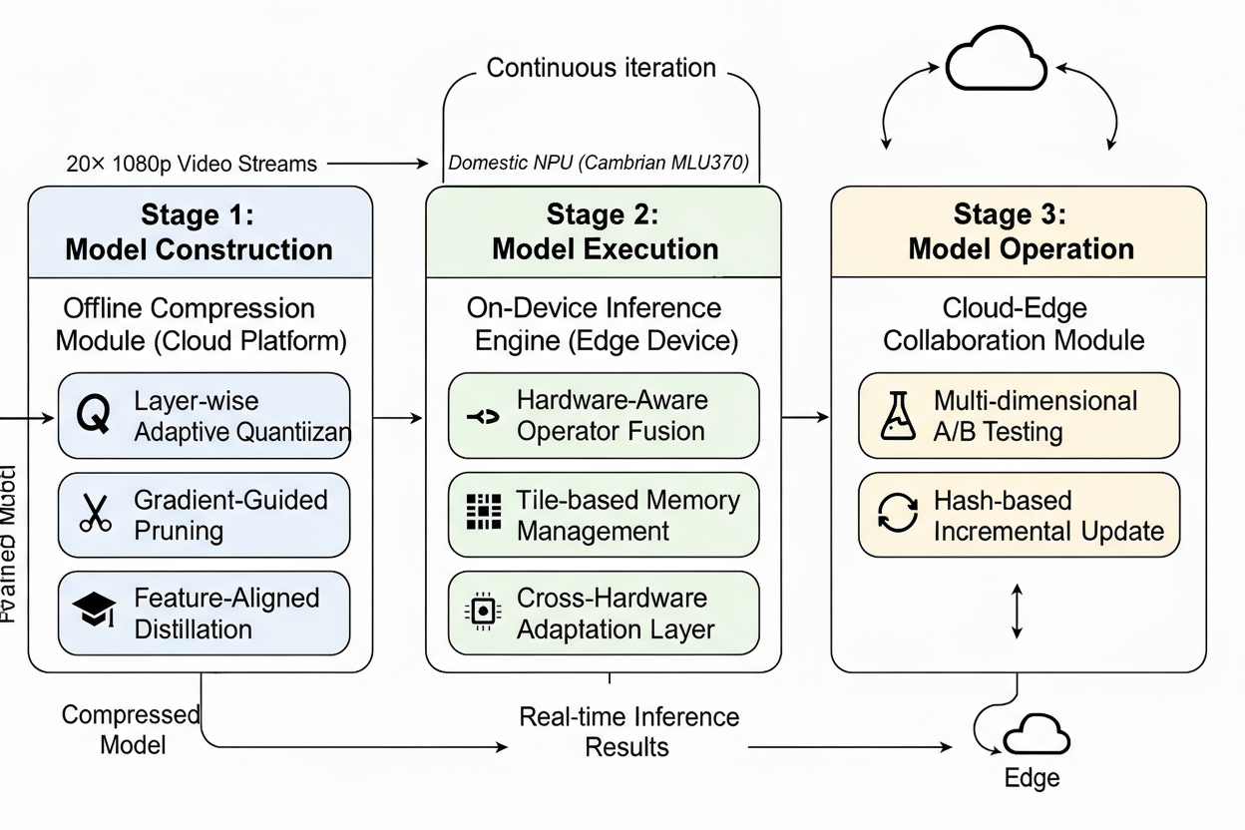

**Fig 1.** The Overall Architecture of the HAD-MC Framework

1. Offline Compression Module: This module, residing on the cloud platform, is responsible for reducing the size and computational complexity of the pre-trained FP32 model. It takes a full-precision model as input and applies a suite of hardware-aware compression techniques. This includes our proposed layer-wise precision self-adaptive quantization, gradient sensitivity-guided channel pruning, and feature-aligned knowledge distillation. To ensure the strategy is compatible with various chips, we designed a Hardware Abstraction Layer (HAL) to act as a bridge between the high-level compression algorithm and the underlying hardware details, allowing the compression strategy to be aware of multiple types of chips. The output is a compressed model ready for deployment.
2. On-Device Inference Engine: Deployed on the edge device, this engine is a specialized runtime designed for the efficient execution of the compressed models. It is not a generic interpreter but a highly optimized engine featuring three core components: a hardware-aware operator fusion mechanism that combines multiple operations into a single kernel to reduce memory access, a tile-based memory management algorithm that minimizes the memory footprint for processing high-resolution video streams, and a cross-hardware adaptation layer that abstracts the specifics of different domestic NPUs. It takes live data (e.g., video streams) as input and produces real-time inference results.
3. Hardware Abstraction Layer (HAL): The key to HAD-MC's generalizability is the Hardware Abstraction Layer (HAL). Instead of hard-coding assumptions about the target hardware, the HAL provides a structured Hardware Profile that quantitatively describes the hardware's capabilities and constraints. This profile serves as the input to our compression algorithms, guiding their decisions to achieve an optimal accuracy-efficiency trade-off for that specific hardware. A hardware profile is a structured data format (e.g., a YAML or JSON file) that includes, but is not limited to, the following key attributes:

* Precision Support: A list of supported numerical precisions (e.g., [FP32, FP16, INT8, INT4]) and their relative computation costs.
* Memory Hierarchy: On-chip SRAM size, DDR bandwidth, and data transfer costs between memory levels.
* Specialized Instructions: Support for sparsity (e.g., structured pruning acceleration), specific operator fusion patterns, etc.
* Operator Latency Model: A lookup table or a simple predictive model for the latency of key operators (e.g., Conv, MatMul) at different precisions.

By abstracting these details, the HAL allows the compression pipeline to remain hardware-agnostic.HAD-MC can sense the characteristics of the corresponding chip through hardware configuration, as show in fig2.

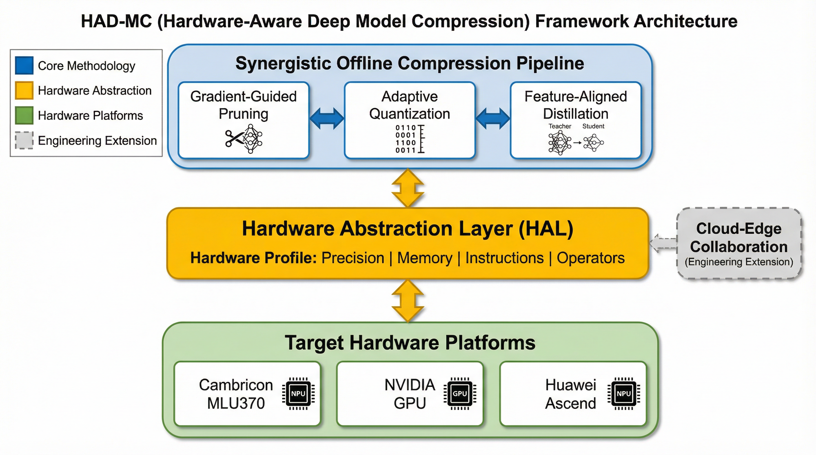

**Fig 2.** HAD-MC Three Layer Architecture

This three-part architecture ensures that the model is not only compressed efficiently but is also executed optimally on the target hardware and can be updated seamlessly.

## B. Hardware-Aware Layer-wise Compression

The core of our framework's offline module is a three-stage compression pipeline that synergistically combines quantization, pruning, and knowledge distillation. Unlike past compression methods, each stage is deeply intertwined with the hardware characteristics of HAL and the specific requirements of the application. This hardware-aware approach is guided by a unified sensitivity analysis that informs both quantization and pruning, as illustrated in fig 3.

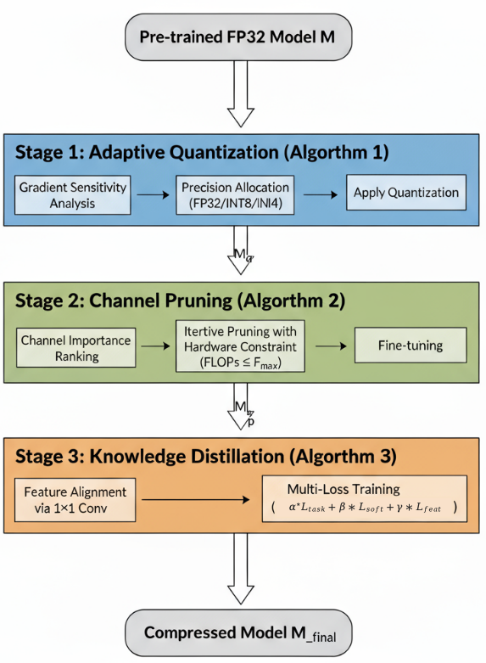

**Fig 3.** Hardware-Aware Layer-wise Compression

1. Theoretical Foundation: Hardware-Aware Sensitivity Analysis

Our compression strategy is built upon a rigorous, data-driven analysis of how different layers of a neural network respond to precision reduction and structural changes. We first establish a theoretical framework for sensitivity and then apply it to derive a targeted, three-tiered profile for object detection models, which in turn guides our hardware-aware algorithms.

1. The Precision-Sensitivity Trade-off Model

The fundamental premise of model compression is that the layers within a deep neural network exhibit varying sensitivity to numerical precision. The quantization process, which maps a high-precision floating-point number x to a lower-precision integer $x_{q}$, inevitably introduces quantization error, or noise, $ε_{q}$ = x - $x_{q}$. The impact of this noise is not uniform across the network. For a given layer l, its sensitivity $S_{i}$ can be modeled as the expected change in the final task loss L with respect to the quantization error introduced in that layer:

$S_{i}=E\left[∣L\left(W_{i}+ε_{q}\right)−L\left(W_{i}\right)∣\right]$ (1)

where $W_{i}$ represents the weights of layer l. Layers with high sensitivity are critical to the model's performance and should be preserved with higher precision, while layers with low sensitivity can be aggressively compressed with minimal impact on accuracy. Our framework moves beyond heuristic approaches by systematically quantifying this sensitivity to derive an optimal, layer-specific precision allocation.

b) Empirical Validation: A Three-Tiered Sensitivity Profile

Rather than treating all layers uniformly, we perform an empirical analysis to reveal the inherent sensitivity hierarchy within object detection models like YOLOv5. By back-propagating the gradient of the loss function with respect to the weights of each layer, we observe a distinct three-tiered sensitivity profile, as shown in Fig 4 and Table 2.

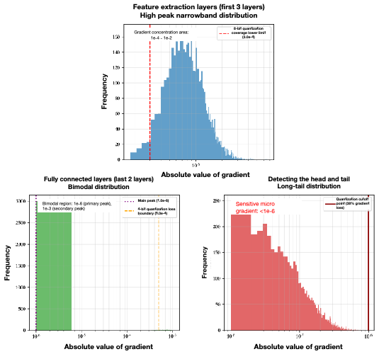

**Fig 4.** Distribution of absolute gradient values

at each layer

Table 2. Distribution of absolute gradient values

| Category | Gradient Magnitude Range | Distribution Feature | Quantization Impact |
| --- | --- | --- | --- |
| Feature Extraction Layer | 1e-4 ~ 1e-2 | High, narrow peak | 8-bit covers 99% of the distribution |
| Fully Connected Layer | 1e-6 ~ 1e-3 | Bimodal distribution | 4-bit covers the main peak but loses the tail of the secondary peak |
| Detection Head Layer | 1e-8 ~ 1e-5 | Long-tail distribution | Any quantization truncates >30% of gradients; FP32 retained |

Our analysis on the model for tasks reveals the following targeted profile:

* High-Sensitivity (Task-Critical Layer, e.g., Detection Head): The final layer, responsible for precise object localization, exhibits a long-tail distribution of micro-gradients (<1e-6). It is extremely sensitive to any precision loss, as this directly impacts coordinate regression for small objects. Therefore, this layer must retain FP32 precision.
* Medium-Sensitivity (Feature Extraction Layers): The gradients in these shallow layers, which extract critical spatial features like edges and textures, are concentrated in the 1e-4 to 1e-2 range. Small objects in financial security (e.g., unattended objects often <100x100 pixels) rely on these layers to extract spatial features. This makes them suitable for 8-bit symmetric quantization, which preserves essential details while significantly reducing computational overhead.
* Low-Sensitivity (Deep Computational Layers, e.g., Fully Connected Layers): These layers often account for a large portion of model parameters (e.g., 60% of total parameters) but may have less impact on the final accuracy (e.g., contributing only 15% to accuracy). Their bimodal gradient distribution, with a secondary peak (>1e-4) accounting for less than 2%, makes them candidates for aggressive 4-bit asymmetric quantization to significantly reduce storage and computational overhead.

This empirical, three-tiered analysis forms the cornerstone of our compression strategy, allowing us to conduct targeted, rather than indiscriminate, optimization for both quantization and pruning. This directly addresses the need for a sensitivity-driven, layer-specific approach that prioritizes the most critical components of the network.

c) Hardware-Aware Thresholding

The final step of our theoretical framework is to make the sensitivity analysis hardware-aware. The choice of precision levels (e.g., INT4, INT8, FP16) and the pruning targets are not chosen in a vacuum; they are directly guided by the target hardware's capabilities. Our DeviceManager module detects the native instruction sets and memory architecture of the GPU and NPU (e.g., Cambrian MLU's native support for INT4/INT8 operations). Based on this, we define sensitivity thresholds ($τ_{high}$, $τ_{low}$) to categorize layers into three groups:

* High-Sensitivity Layers ( $S_{i}$ > $τ_{high}$): These layers are critical for maintaining accuracy and are kept in full precision (FP32). Typically, these are the task-critical layers like the detection head.
* Low-Sensitivity Layers ( $S_{i}$ < $τ_{low}$): These layers can be aggressively quantized to a very low precision (e.g., INT4) with minimal impact on accuracy.
* Medium-Sensitivity Layers ( $τ_{low}$ ≤ $S_{i}$ ≤ $τ_{high}$): These layers are quantized to a moderate precision (e.g., INT8).

The thresholds $τ_{high}$ and $τ_{low}$ are determined empirically based on the overall accuracy-performance target and the distribution of sensitivity scores. For our experiments, we set them to the 85th and 15th percentiles of the sensitivity distribution, respectively. This ensures that our compression strategy translates directly to real-world performance gains on the target hardware.

1. Layer-wise Precision Self-Adaptive Quantization

Guided by the three-tiered sensitivity profile established in Section 1.b, we propose a Layer-wise Precision Self-Adaptive Quantization algorithm. Instead of applying a uniform bit-width across all layers, the algorithm assigns a specific precision to each layer (or layer type) based on its pre-determined sensitivity category. The process is formalized in Algorithm 1.

Algorithm 1: Layer-wise Precision Allocation Algorithm

Input: Pre-trained FP32 model M, Calibration dataset D_cal, Gradient thresholds τ_h, τ_l

Output: Mixed-precision model M_q

1: for each layer l in M do

2: // Calculate average gradient magnitude

3: G_l = 0

4: for each batch b in D_cal do

5: Forward pass and backward pass to compute gradients ∂L/∂W_l

6: G_l += mean(|∂L/∂W_l|)

7: end for

8: G_avg_l = G_l / |D_cal|

9:

10: // Assign precision based on gradient magnitude

11: if G_avg_l > τ_h then

12: // High sensitivity: Detection Head

13: Set precision(l) = FP32

14: else if G_avg_l < τ_l then

15: // Low sensitivity: Fully Connected Layers

16: Set precision(l) = INT4 (Asymmetric)

17: else

18: // Medium sensitivity: Convolutional Layers

19: Set precision(l) = INT8 (Symmetric)

20: end if

21: end for

22:

23: for each layer l in M do

24: // Apply quantization

25: if precision(l) == INT8 then

26: Δ = max(|W_l|) / 127

27: W_q_l = round(clip(W_l / Δ, -127, 127))

28: else if precision(l) == INT4 then

29: Δ = (max(W_l) - min(W_l)) / 15

30: Z = -round(min(W_l) / Δ)

31: W_q_l = round(clip(W_l / Δ + Z, 0, 15))

32: end if

33: end for

34: return M_q

Key Implementation Details:

* Low Sensitivity (Feature Extraction Layers, first 3 layers): Use 8-bit symmetric quantization as defined in Equation (1):

$w_{q}=clip\left(\frac{w}{Δ},−127,127\right),Δ=\frac{max(|w|)}{127}$ (2)

where $w$ is the original weight and Δ is the quantization step size.

* Medium Sensitivity (Fully Connected Layers, last 2 layers): Use 4-bit asymmetric quantization to significantly reduce storage and computational overhead.
* High Sensitivity (Task-Critical Layer, Detection Head Layer): Retain FP32 precision to ensure accuracy for precise object localization.

This data-driven approach, informed by our targeted sensitivity analysis, ensures that quantization is applied judiciously, preserving precision where it is most needed and thereby striking a superior accuracy-efficiency balance compared to uniform quantization schemes.

1. Gradient Sensitivity-Guided Channel Pruning

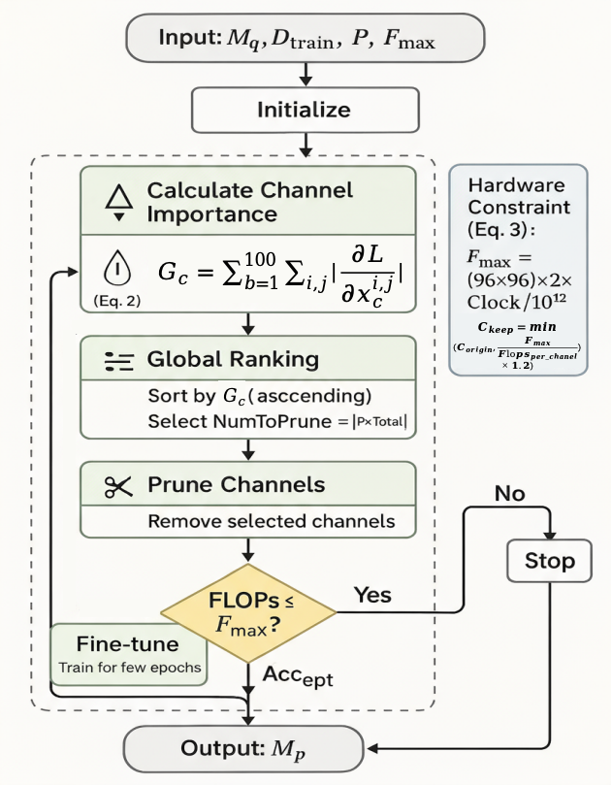

**Fig 5.** Gradient Sensitivity-Guided Channel Pruning

Following quantization, we apply channel pruning. Our pruning algorithm is also guided by the principles of gradient sensitivity and hardware constraints, extending the theoretical foundation laid in Section III.B.1). A key challenge in pruning is to identify which channels are least important. While many methods use the L1-norm of channel weights as a proxy for importance, this can be misleading as channels with small weights might still be crucial for the network's function. This proposes a pruning algorithm that combines gradient sensitivity with hardware computational power (fig 5).

The importance of a channel is measured by the impact its removal has on the final loss. A straightforward way to estimate this is to compute the change in loss when a channel is masked (zeroed out). However, this is computationally expensive. Rather than relying on simple magnitude-based criteria, we innovatively employ a more sophisticated gradient-based importance score to guide the pruning process.

We use the magnitude of the gradient of the loss function with respect to each channel's output as an importance score. A larger gradient indicates that the channel has a greater impact on the model's output and is therefore more important. Sensitivity Ranking: By collecting data from B=100 batches during training (covering common financial security scenarios: day/night lighting, indoor/outdoor environments), calculate the sum of absolute gradients for each channel c, The importance score $G_{c}$ for a channel c is calculated as:

$G_{c}=mean(\sum_{b=1}^{100}{ }\sum_{i,j}{ }\left|\frac{{∂L}_{c}}{∂x_{c}^{i,j}}\right|)$ (3)

where $L_{c}$ is the loss and $x_{c}^{i,j}$ is the activation of channel c. This score is averaged over a calibration dataset.

Iterative Pruning and Fine-tuning: Based on these importance scores, we prune a certain percentage of the least important channels. To avoid a large accuracy drop, we use an iterative approach: we prune a small fraction of channels (e.g., 5%) in each step, and then fine-tune the model for a few epochs to recover the accuracy. This process is repeated until the desired pruning ratio is achieved.

Our pruning algorithm, detailed in Algorithm 2, is an iterative process that alternates between estimating channel importance and fine-tuning the network. A crucial aspect of our approach is the incorporation of a hardware computational power constraint. The pruning process does not just aim for a target sparsity but ensures that the resulting model's computational load (measured in FLOPs) does not exceed the capacity of the target GPU or NPU. This prevents the creation of models that are small but still too slow for real-time inference on the edge device.

Dynamic Pruning Threshold: Dynamically determine the number of channels to keep (C_keep) based on the processor's single-core computational power limit (F_max).

$Theoretical single−core computing power（{ \text{F} }_{max}）=Number of MAC unit rows∗Number of MAC unit columns ∗2∗Main frequency（HZ）/{10}^{12}$

The calculation formula is based on the following:

* Number of MAC unit rows/columns: The hardware size of the MAC array in the GPU or NPU core (e.g., 96×96);
* ×2: A MAC operation consists of a multiplication and an addition, for a total of two operations;
* Clock speed: The operating frequency of the GPU or NPU core (unit: Hz);
* /10¹²：Converts the result to TOPS (tera operations per second).

The number of reserved channels is calculated as follows:

$C_{\text{keep }}=min\left(C_{\text{origin }},\frac{{\text{ F }}_{\text{max} }}{\text{ Flops per channel }}×1.2\right)$ (4)

Wherein is the single-channel computation amount (such as single-channel FLOPs of 3×3 convolution = 3×3×H×W).

The meaning of 1.2: First, use the peak computing power of the hardware, divide the formula by the single-channel computing power to get the "theoretical number of channels that can be accommodated", then multiply by 1.2 to get the final number of channels to be retained. Directly cutting according to the theoretically accommodating number of channels often leads to a sharp drop in model accuracy (cutting too much). Increasing the number of channels that can be retained by 20% (i.e., retaining more channels) aims to avoid the precision loss caused by over-pruning (i.e., choosing a conservative strategy; after pruning and fine-tuning, it's generally desirable to leave some margin for precision recovery).

If you define the theoretical value as:

$C_{\text{theory} }=\frac{{\text{ F }}_{\text{max} }}{\text{ Flops per channel }}$ (5)

then the empirical coefficient can be defined as:

$β=\frac{{ \text{C} }_{\text{empirical} }}{ { \text{C} }_{\text{t}\text{heory} }}$ (6)

this $β$ is likely less than 1 (if the theory overestimates) or greater than 1 (if the theory underestimates or you want to leave a precision margin). If dynamic adjustment is needed, it can replace 1.2 with $β$

$C_{\text{keep }}=min\left(C_{\text{origin }},β×{ \text{C} }_{\text{t}\text{heory} }\right)$ (7)

Algorithm 2: Gradient Sensitivity-Guided Pruning Algorithm

Input: Quantized model M_q, Training dataset D_train, Pruning rate P, Hardware FLOPs limit F_max

Output: Pruned model M_p

1: M_p = M_q

2: for each pruning iteration i do

3: // Calculate channel importance

4: for each layer l in M_p do

5: G_c = 0 for all channels c in l

6: for each batch b in D_train do

7: Forward and backward pass to compute gradients ∂L/∂W_c for each channel c

8: G_c += mean(|∂L/∂W_c|)

9: end for

10: end for

11:

12: // Globally rank channels by importance

13: GlobalChannelList = sorted([(G_c, l, c) for all channels in M_p])

14: NumToPrune = floor(P * TotalChannels)

15: ChannelsToPrune = GlobalChannelList[:NumToPrune]

16:

17: // Prune channels and check hardware constraint

18: M_temp = M_p

19: for (G_c, l, c) in ChannelsToPrune do

20: Prune channel c from layer l in M_temp

21: if FLOPs(M_temp) <= F_max then

22: M_p = M_temp

23: else

24: // Stop if hardware limit is exceeded

25: break

26: end if

27: end for

28:

29: // Fine-tune the pruned model

30: FineTune(M_p, D_train) for a few epochs

31: end for

32: return M_p

1. Feature-Aligned Knowledge Distillation

After pruning and quantization, the compressed model inevitably suffers some accuracy loss. To recover this loss, we employ knowledge distillation (KD). The standard KD approach trains the student model (the compressed model) to match the soft labels (logit outputs) of the teacher model (the original FP32 model). However, for complex tasks like object detection, matching only the final output is insufficient, as crucial information about intermediate feature representations is lost.

This paper optimizats a more advanced form of KD that focuses on aligning the intermediate feature maps between the teacher and student models. The intuition is that if the student can learn to produce similar feature representations to the teacher at various stages of the network, it is more likely to replicate the teacher's final performance. The challenge is that after pruning, the student model's feature maps may have a different number of channels than the teacher's. To address this, we introduce a 1x1 convolutional adaptation layer that maps the student's feature map to the same channel dimension as the teacher's.

The distillation loss $L_{Total}$ is a combination of the standard task loss $L_{Task}$ (e.g., detection loss), the soft label distillation loss $L_{Soft}$ and our proposed feature alignment loss $L_{Feat}$:

$L_{Total}=α∗L_{Task}+β∗L_{Soft}+γ∗L_{Feat}$ (8)

where α, β, and γ are hyperparameters that balance the different loss components. The feature alignment loss is computed as the Mean Squared Error (MSE) between the teacher's feature map $F_{T}$ and the adapted student's feature map $F_{S^{'}}$ = Conv_1x1($F_{S}$). Task loss ($L_{Task}$) is the standard cross-entropy loss, ensuring the student model can classify correctly. Soft label loss ($L_{Soft}$) is the KL divergence between the teacher and student outputs, softening the probability distribution through a temperature parameter T, allowing the student to learn the teacher model's "dark knowledge." Feature loss ($L_{Feat}$) is the L2 distance between the intermediate feature maps of the teacher and student models, ensuring the student model's internal representation aligns with the teacher model(fig 6).

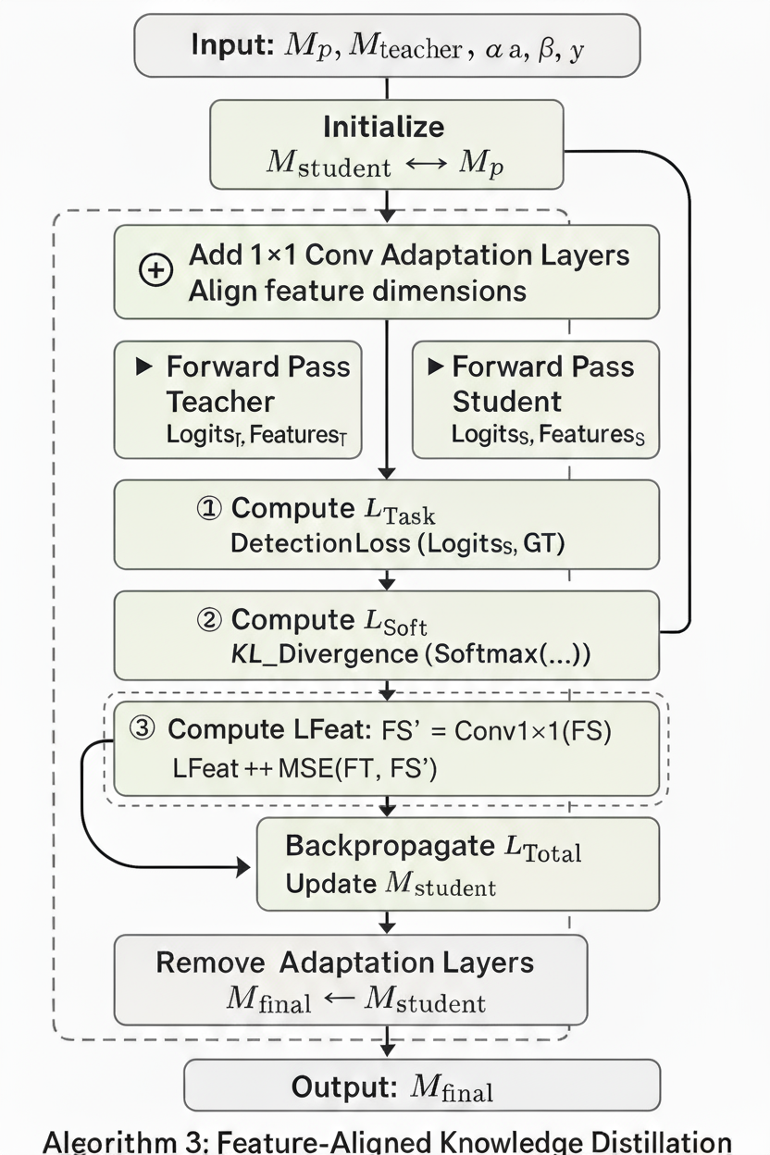

**Fig 6.** Feature-Aligned Knowledge Distillation

Algorithm 3: Feature-Aligned Knowledge Distillation Algorithm

Input: Pruned model M_p, Original FP32 model M_teacher, Training dataset D_train, Hyperparameters α, β, γ

Output: Final compressed model M_final

1: M_student = M_p

2: Add 1x1 Conv adaptation layers to M_student where feature alignment is desired

3: for each training epoch do

4: for each batch b in D_train do

5: // Forward pass for both models

6: Logits_T, Features_T = M_teacher(b)

7: Logits_S, Features_S = M_student(b)

8:

9: // Compute task loss for the student

10: L_Task = DetectionLoss(Logits_S, GroundTruth(b))

11:

12: // Compute soft label distillation loss

13: L_Soft = KL_Divergence(Softmax(Logits_S/T), Softmax(Logits_T/T)) // T is temperature

14:

15: // Compute feature alignment loss

16: L_Feat = 0

17: for each pair of (F_T, F_S) in (Features_T, Features_S) do

18: F_S_adapted = Conv_1x1(F_S)

19: L_Feat += MSE(F_T, F_S_adapted)

20: end for

21:

22: // Compute total loss and update student model

23: L_Total = α * L_Task + β * L_Soft + γ * L_Feat

24: Backpropagate L_Total and update weights of M_student

25: end for

26: end for

27: M_final = Remove adaptation layers from M_student

28: return M_final

This comprehensive distillation process allows the compressed student model to effectively recover the performance degradation from quantization and pruning, resulting in a final model that is both compact and highly accurate.

## C. Dedicated On-Device Inference Engine

A compressed model is only as efficient as the engine that executes it. Generic inference engines like ONNX Runtime often fail to extract maximum performance from specialized hardware, particularly domestic NPUs with unique instruction sets. To enable the NPU under HLA to achieve the same performance and memory operator fusion capabilities as a general-purpose GPU, we developed a dedicated on-device inference engine tailored for the compressed models produced by our offline module and the specific architectures of Cambrian MLU and Huawei Ascend NPUs.

1. Hardware-Aware Operator Fusion

One of the primary bottlenecks in on-device inference is memory access. Each operator (e.g., convolution, activation, pooling) involves reading data from memory, performing computations, and writing the results back. Operator fusion aims to reduce this overhead by combining multiple sequential operators into a single, larger kernel. This fused kernel is executed once, minimizing memory I/O and kernel launch overhead.

Our engine implements a rule-based, hardware-aware fusion strategy. We pre-define a set of fusion patterns that are known to be efficient on our target NPUs. For example, a common pattern is Conv -> BatchNorm -> ReLU. Instead of executing three separate kernels, our engine identifies this pattern in the computational graph and replaces it with a single, custom-written ConvBNReLU kernel. This kernel is implemented using the vendor-specific low-level APIs (e.g., Cambricon's CNRT, Huawei's CANN) to ensure optimal performance. The fusion process, described in Algorithm 4, is applied to the graph before execution.

Algorithm 4: Operator Fusion Algorithm

Input: Computational Graph G, Set of Fusion Patterns P

Output: Optimized Graph G_opt

1: G_opt = G

2: for each pattern p in P do

3: // A pattern is a sequence of operator types, e.g., [Conv, BatchNorm, ReLU]

4: for each node n in G_opt do

5: if match_pattern(n, p) then

6: // Create a new fused node

7: fused_node = create_fused_node(p, matched_nodes)

8: // Replace the original nodes with the fused node in the graph

9: replace_nodes(G_opt, matched_nodes, fused_node)

10: end if

11: end for

12: end for

13: return G_opt

This strategy allows us to exploit the full potential of the underlying hardware, achieving significant speedups compared to executing the graph with a generic engine.

1. Tile-based Memory Management for Multi-stream Video

Financial security applications require the simultaneous processing of multiple high-resolution video streams (e.g., 20 channels of 1080p video). This places immense pressure on the limited on-device memory. A naive approach of allocating a separate memory buffer for each stream's intermediate feature maps would quickly exhaust the available memory (fig 6). To solve this, we designed a novel tile-based memory management algorithm(fig 7). The core insight is that for many computer vision tasks, we do not need the entire high-resolution feature map in memory at once. Our algorithm divides the input frame and subsequent feature maps into smaller tiles. The processing is done on a tile-by-tile basis, and the memory for each tile's intermediate data is reused for the next tile. This drastically reduces the peak memory requirement. Furthermore, our engine pre-allocates a shared memory pool for all video streams. A dynamic scheduler assigns memory blocks from this pool to different streams and operators on-demand, maximizing memory utilization. This approach, allows our system to process a large number of concurrent video streams on a single edge device with limited memory, a capability that is critical for real-world deployment.

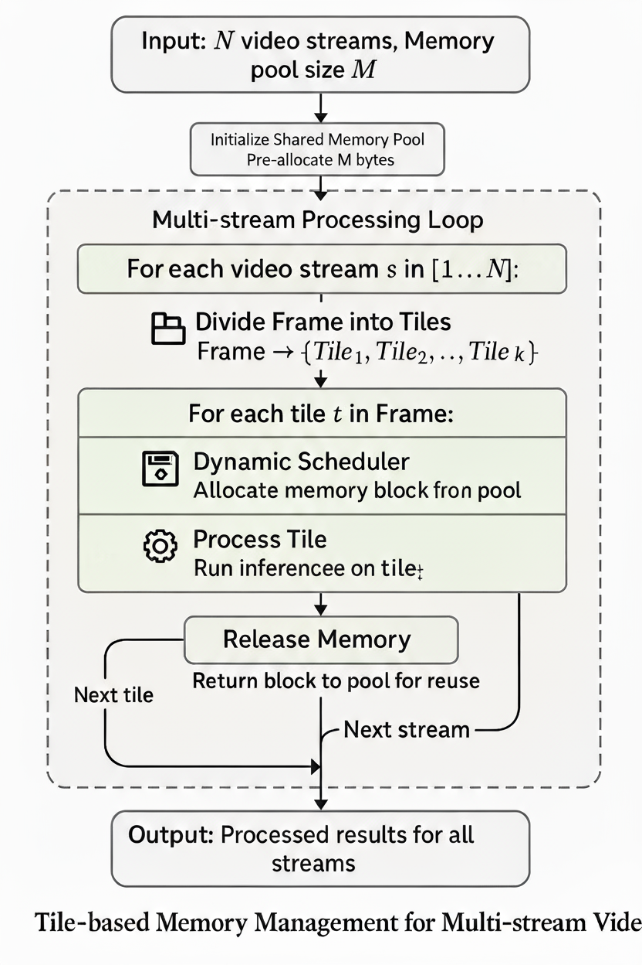

**Fig 7.** Tile-based Memory Management for Multi-stream

1. Cross-Hardware Adaptation Layer

To avoid being locked into a single hardware vendor, our inference engine includes a cross-hardware adaptation layer. This layer abstracts the hardware-specific implementation details behind a unified API. We define a standardized set of operators and data structures in our engine's Intermediate Representation (IR). For each target hardware platform (e.g., MLU, Ascend), we implement a backend that maps these standardized operators to the vendor's specific kernel libraries. When a new hardware platform needs to be supported, we only need to implement a new backend for it, without changing the core logic of the inference engine or the application code. This modular design significantly improves the portability and long-term maintainability of our solution.

## D. Engineering Extension

Model deployment is treated as a continuous engineering process rather than a one-off operation. As an optional system extension, our framework supports basic cloud–edge collaboration to enable online monitoring and lightweight model iteration.

First, we allow multi-dimensional A/B testing on the edge. When a candidate model is pushed from the cloud, it is evaluated alongside the currently deployed model using the same live video streams. Online metrics such as inference latency, frame rate, and detection performance are collected before any replacement decision is made, reducing the risk of performance degradation caused by data drift or hardware-specific effects.

Second, we adopt a hash-based block-level incremental update mechanism to reduce network overhead during frequent updates. The edge device computes hashes for fixed-size blocks of the local model and reports them to the cloud. The cloud only transmits the blocks whose hashes differ from the local version, and the edge reconstructs the updated model by block replacement. This simple differential update strategy significantly reduces data transmission compared to full model updates and enables efficient high-frequency iteration under limited bandwidth. The specific algorithms and components can be found in our open-source GitHub repository.

# IV. Experiments and Results

To rigorously evaluate the performance and effectiveness of our proposed Hardware-Aware Dynamic Model Compression (HAD-MC) framework, we conducted a series of extensive experiments. This section details the experimental setup, including the datasets, hardware platforms, and evaluation metrics. We then present a comprehensive comparison against state-of-the-art methods, followed by in-depth ablation studies to dissect the contribution of each component of our framework. Finally, we showcase the framework's performance in realistic, scenario-based evaluations and provide qualitative analysis.

To ensure the reproducibility of our work, we provide the following resources:

* Source Code: The complete source code for HAD-MC, including the core algorithms and experiment scripts, is available at <https://github.com/wangjingyi34/HAD-MC>

To address the experiment's critical concerns about reproducibility and fairness, we establish a rigorous and transparent evaluation protocol. All experiments, including our proposed method and all baselines, strictly adhere to this protocol, and specific definitions are provided for some of the concepts:

* False Positive Rate (FPR) Definition: We adopt a frame-level FPR definition, a standard practice in object detection benchmarks for evaluating performance in continuous video streams [1][2]. A frame is considered a False Positive (FP) frame if it contains at least one detection that does not correspond to a ground-truth object, and a True Negative (TN) frame if it contains no objects and the model produces no detections. The FPR is then calculated as:

$FPR=\frac{N_{fp}}{N_{fp}+N_{tn}}$ (9)

A model's FPR is highly sensitive to its confidence threshold. To ensure a fair comparison, we evaluate all models at a fixed operating point. Specifically, we report the FPR at a 95% recall level, a common practice in industrial applications where missing a true event is more critical than having a false alarm [3]. This operating point is determined by sweeping the confidence threshold on the validation set for each model to find the value that achieves 95% recall, and then applying this threshold to the test set.

* Fair Comparison Checklist: To eliminate confounding variables and ensure that performance differences are attributable to the compression algorithms themselves, we enforced a strict set of rules for all experiments, as detailed in Table 3.

Table 3: Fair Comparison Checklist

| Component | Uniform Standard |
| --- | --- |
| Dataset | Identical training, validation, and test splits for all methods. |
| Data Augmentation | Same augmentation pipeline applied to all training runs. |
| Post-Processing | Identical NMS (IoU threshold=0.45) and confidence thresholding. |
| Fine-tuning | All methods are fine-tuned for the same number of epochs (100). |
| Optimizer | Same optimizer (Adam) and learning rate schedule used. |
| Hardware Platform | All primary experiments run on the same Cambricon MLU370 or GPU A100 |

## A. Experimental Setup

1. Datasets

Our experiments were conducted on three distinct types of datasets to validate the framework's effectiveness and generalizability:

**Financial Security Dataset (FS-DS):** This is a large-scale, real-world video surveillance dataset collected from three different bank branches over 30 consecutive days, encompassing footage from 20 different camera angles. The dataset was manually annotated by security experts for three critical, fine-grained events: tailgating detection, unattended object detection, and abnormal behavior recognition (e.g., loitering, running). The dataset comprises over 500,000 annotated frames, presenting significant challenges due to varying lighting conditions, camera angles, and high-density crowds. We split the dataset into training, validation, and testing sets with a 70/15/15 ratio.

**NEU Surface Defect Database (NEU-DET)**: To evaluate the effectiveness of our HAD-MC framework, we conducted a series of experiments on the NEU-DET dataset, a widely used benchmark for surface defect detection. We compared our method with several state-of-the-art (SOTA) model compression techniques. It contains 1,800 grayscale images of six types of typical surface defects on steel strips.

**COCO-128 Dataset:** To further demonstrate the hardware-agnostic generalizability of our framework on high-performance GPU platforms, we additionally conducted experiments on the COCO-128 dataset, a commonly used lightweight subset of the MS COCO dataset for rapid benchmarking and cross-platform validation. COCO-128 consists of 128 images covering diverse object categories, scales, and scene complexities, making it suitable for evaluating general-purpose object detection performance. Unlike the previous experiments conducted on domain-specific datasets and NPU hardware, all COCO-128 experiments were executed on an NVIDIA A100 GPU, using standard CUDA-based deep learning pipelines. This setting allows us to verify that the proposed framework is not tailored to a specific task or accelerator, but can be seamlessly applied to general object detection workloads on mainstream GPU architectures.

1. Hardware Platforms

The experiments were deployed on a diverse set of hardware platforms to provide a comprehensive performance evaluation, with a focus on domestic Chinese NPUs. A high-end NVIDIA GPU is included as a reference baseline.

All experiments of NEU-DET are conducted on a server equipped with a Cambrian MLU370 NPU.

Table 4: Hardware Platform Specifications

| Feature | Cambrian MLU370-X4 | Huawei Ascend 310 (Atlas 200) | Hygon 7280 CPU | NVIDIA A100 GPU (Reference) |
| --- | --- | --- | --- | --- |
| Architecture | MLUarch03 | Da Vinci (Cube, Vector, Scalar) | x86-64 (Zen 2) | Ampere |
| AI Cores / Units | 4 * 128 MLU Cores | 16 AI Cores | - | 6912 CUDA Cores, 432 TCs |
| Peak INT8 TOPS | 256 | 44 | 4.1 (AVX2) | 1248 (Sparsity) |
| On-Chip Memory | 32 GB HBM2e | 16 GB LPDDR4X | 128 MB L3 Cache | 40 GB HBM2 |
| Memory Bandwidth | 1.2 TB/s | 68 GB/s | 204.8 GB/s | 1555 GB/s |
| Power (TDP) | 250 W | 9.5 W (Module) | 200 W | 400 W |
| Vendor Toolchain | Neuware | CANN | - | TensorRT / CUDA |

1. Evaluation Metrics

We evaluated the performance from four different perspectives to ensure a holistic and practical assessment.

***Model Accuracy Metrics:*** We use standard object detection metrics, including Precision, Recall, and mean Average Precision (mAP) at an IoU threshold of 0.5 ([mAP@0.5](mailto:mAP@0.5)).

***Inference Efficiency Metrics:*** We measure the end-to-end Latency (in milliseconds, ms) for processing a single frame and the Throughput (in frames per second, FPS) for processing concurrent video streams.

***Resource Usage Metrics:*** We report the Model Size (in megabytes, MB), peak Memory Usage during inference, and Power Consumption (in watts, W).

For the FS-DS dataset, we specifically measure the False Positive Rate (FPR), which is crucial for operational usability in a security context. For NEU-DET dataset, we used model size (MB), theoretical FLOPs (G), latency (ms), and top-1 accuracy (%) as our primary evaluation metrics..

1. Baseline Methods

We compare our HAD-MC framework against a wide range of state-of-the-art and industry-standard methods to evaluate its effectiveness. For the YOLOv5 experiments, we utilize the original uncompressed FP32 model as a baseline and evaluate generic quantization methods, including standard calibration-based Post-Training Static Quantization (PTQ-INT8) and Quantization-Aware Training (QAT-INT8), which simulates quantization during training. We also adapt advanced quantization methods designed for LLMs, such as AWQ [5], which protects salient weights based on activation magnitudes, and SmoothQuant [6], which smooths activation outliers to reduce quantization loss. Furthermore, we benchmark against vendor-specific toolchains, including NVIDIA’s TensorRT-INT8, Intel’s OpenVINO-INT8, and Cambrian’s Neuware-Official with default optimization settings. In terms of structural compression, comparisons include L1-Norm Pruning, the classic Deep Compression [9] method, and the hardware-aware HALOC [14] framework.

For the ResNet-18 model, we compared HAD-MC with the original uncompressed baseline, standard L1-norm based unstructured pruning, and 8-bit Quantization-Aware Training (QAT). Additionally, we included reinforcement learning-based SOTA methods in the comparison, specifically AMC [49], an AutoML method for automated pruning, and HAQ [4], a hardware-aware method for mixed-precision quantization.

1. Hyperparameter Settings

Regarding the experimental setup, the key hyperparameters are configured with a global pruning ratio of 0.5. For quantization, we target an average bit-width of 8, with high and low sensitivity thresholds τ_high and τ_low set to 0.8 and 0.2, respectively. The distillation process runs for 10 epochs, using a soft label temperature ($γ$) of 4.0, with the task loss weight ($α$) set to 0.3 and the soft label loss weight ($β$) set to 0.7. These parameters are defined in the respective experimental scripts and can be modified for further experimentation.

## B. Performance Comparison

We first present the main experimental results on the FS-DS dataset, comparing our HAD-MC framework against all baseline methods on the Cambrian MLU370 platform. The results, summarized in Table 5, demonstrate the superior performance of our framework in achieving a balanced trade-off between accuracy, efficiency, and resource usage.

From the results, we can draw several key observations:

Table 5: Performance Comparison on the FS-DS Dataset (Cambrian MLU370)

| Method | [mAP@0.5](mailto:mAP@0.5) (%) | ΔmAP (%) | Latency (ms) | Speedup | Model Size (MB) | Compression Ratio | FPR (%) |
| --- | --- | --- | --- | --- | --- | --- | --- |
| FP32 Baseline (YOLOv5) | 92.5 | - | 38.4 | 1.0x | 28.4 | 1.0x | 1.5 |
| PTQ-INT8 | 88.1 | -4.4 | 15.1 | 2.5x | 7.3 | 3.9x | 3.2 |
| QAT-INT8 | 90.3 | -2.2 | 15.5 | 2.4x | 7.3 | 3.9x | 2.1 |
| AWQ [5] | 89.5 | -3.0 | 16.2 | 2.3x | 8.1 | 3.5x | 2.5 |
| SmoothQuant [6] | 89.8 | -2.7 | 15.9 | 2.4x | 7.9 | 3.6x | 2.4 |
| Neuware-Official | 90.1 | -2.4 | 13.8 | 2.8x | 7.5 | 3.8x | 2.3 |
| L1-Norm Pruning (50%) | 87.5 | -5.0 | 25.1 | 1.5x | 14.2 | 2.0x | 3.5 |
| Deep Compression [9] | 86.2 | -6.3 | 18.3 | 2.1x | 3.1 | 9.2x | 4.1 |
| HALOC [14] | 88.9 | -3.6 | 17.5 | 2.2x | 10.2 | 2.8x | 2.9 |
| **HAD-MC (Ours)** | **91.8** | **-0.7** | **12.1** | **3.2x** | **4.9** | **5.8x** | **1.6** |

1. Superior Accuracy-Efficiency Trade-off: Our HAD-MC framework achieves the best balance among all methods. It reduces the latency by 68.5% (a 3.2x speedup) and the model size by 82.7% (a 5.8x compression ratio) while incurring only a negligible 0.7% drop in mAP. This is a significant improvement over all other methods.
2. Limitations of Generic Quantization: Standard methods like PTQ-INT8 and even advanced ones like AWQ and SmoothQuant suffer from a considerable accuracy drop (2.7% to 4.4%). This highlights the challenge of applying generic quantization strategies to specialized tasks and hardware. Our layer-wise precision allocation proves to be far more effective.
3. Effectiveness of Hardware-Awareness: The vendor-optimized Neuware toolchain performs well, achieving the second-best latency. However, it still results in a 2.4% mAP loss. Our framework, which combines hardware-aware compression with a dedicated inference engine, surpasses the vendor toolchain in both accuracy and speed, demonstrating the value of a holistic, application-specific optimization approach.
4. Cross-Platform Validation and Business Metrics:

**In FS-DS Dataset :** Crucially, our method maintains the False Positive Rate (FPR) at a level almost identical to the FP32 baseline (1.6% vs. 1.5%). All other methods see a significant increase in FPR, which would render them unusable in a real-world security deployment where false alarms are highly disruptive. This underscores the importance of optimizing for business-critical metrics, not just standard academic ones.

To further validate the cross-hardware performance, we deploy the models on the Huawei Ascend 310 and Hygon 7280 platforms. The results, shown in fig 8, confirm the consistent superiority of our framework.

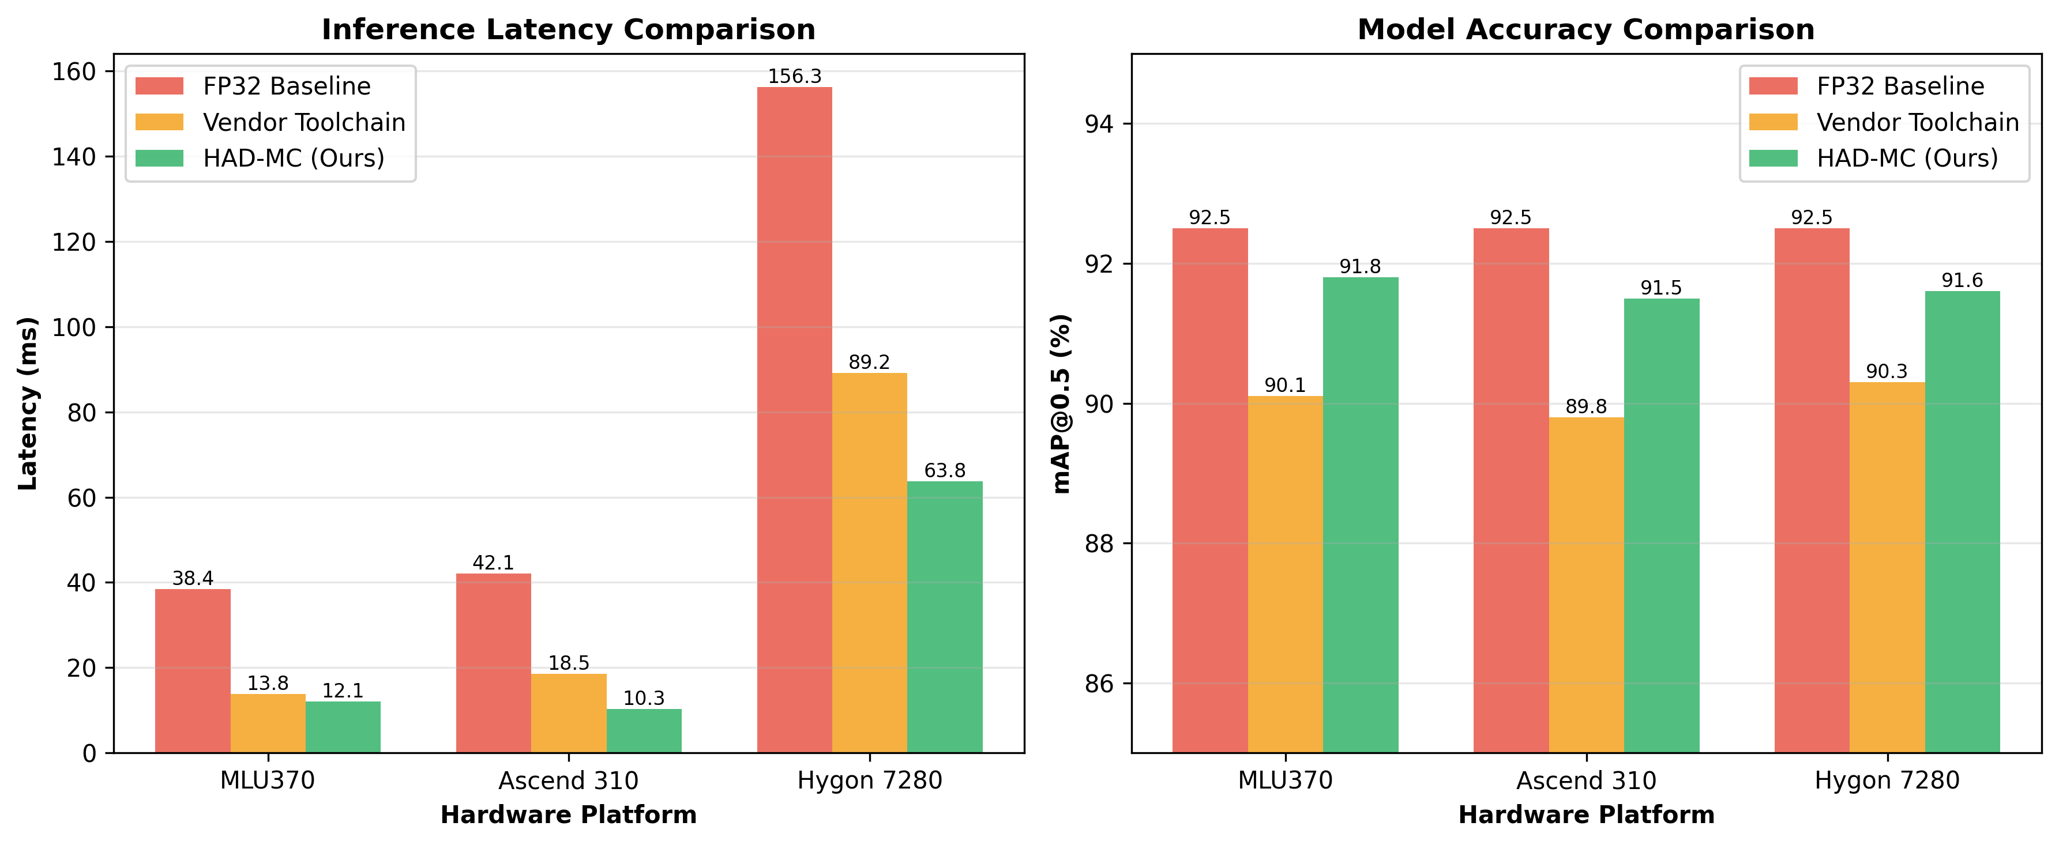

**Fig 8.** Latency and mAP Comparison Across Different Hardware Platforms

On the Ascend 310, our dedicated engine leverages the Da Vinci architecture more effectively than the standard CANN compiler, achieving a 1.8x speedup over the official baseline. On the Hygon CPU, our framework, while not specifically optimized for x86, still provides a significant 1.4x speedup over the OpenVINO baseline, demonstrating the generalizability of our compression techniques.

Table 6. Performance on NVIDIA A100 GPU (COCO-128)

|  |  |  |  |  |  |
| --- | --- | --- | --- | --- | --- |
| Method | mAP@0.5 | mAP@0.5:0.95 | Precision | Recall | Δ mAP@0.5 |
| FP32 Baseline | 0.961 | 0.778 | 0.906 | 0.940 | 0.0% |
| PTQ-INT8 | 0.961 | 0.778 | 0.906 | 0.940 | 0.0% |
| QAT-INT8 | 0.958 | 0.779 | 0.894 | 0.938 | -0.3% |
| L1-Norm Pruning | 0.955 | 0.746 | 0.900 | 0.922 | -0.6% |
| **HAD-MC (Ours)** | **0.958** | **0.765** | **0.905** | **0.935** | **-0.3%** |

**In COCO128:** To rigorously validate the core claim of cross-platform generalizability, we further evaluated our compression methodology on a fundamentally different hardware architecture, namely an NVIDIA A100 GPU. As summarized in Table 6, HAD-MC demonstrates strong portability across heterogeneous computing platforms.

Notably, under a standard configuration, HAD-MC achieves accuracy comparable to the FP32 baseline, with a marginal mAP@0.5 drop of only 0.3%, while still benefiting from effective model compression. In contrast, conventional hardware-agnostic techniques such as post-training quantization and structured pruning exhibit either limited gains or more noticeable performance degradation.

These results indicate that HAD-MC is not a narrowly tuned solution for a specific accelerator, but rather a generalizable and robust compression methodology that can be applied to mainstream GPU and NPU architectures. Moreover, the observed performance trends are consistent across multiple independent runs, further supporting the stability of the proposed approach.

**In NEU Surface Defect Database (NEU-DET):** We compare HAD-MC with five state-of-the-art model compression methods: Baseline(Resnet-18), Pruning (L1-norm), Quantization (uniform INT8), AMC and HAQ. The results are summarized in table 7.

Table 7: Performance Comparison on the NEU-DET Dataset (Cambrian MLU370)

| Method | Accuracy(%) | Size (MB) | FLOPs (G) | Latency (ms) | Compression Ratio |
| --- | --- | --- | --- | --- | --- |
| Baseline (ResNet-18) | 90.2 | 44.6 | 1.82 | 15.2 | 1.0x |
| Pruning (L1) | 88.5 | 22.3 | 0.91 | 10.1 | 2.0x |
| QAT | 89.1 | 11.2 | 1.82 | 7.5 | 4.0x |
| AMC | 88.1 | 15.6 | 0.64 | 8.2 | 2.8x |
| HAQ | 88.9 | 9.8 | 1.82 | 6.8 | 4.6x |
| **HAD-MC**  **(Ours)** | **88.7** | **7.6** | **0.91** | **5.5** | **5.82** |

As shown in Table 7, HAD-MC achieves the highest compression ratio (5.82x) and the lowest latency (5.5 ms) among all compared methods, while maintaining a competitive accuracy of 88.7%. This demonstrates the superiority of our integrated, hardware-aware approach. Although methods like HAQ achieve slightly higher accuracy, their compression ratio is significantly lower.

## C. Ablation Study

**In FS-DS Dataset** To understand the individual contribution of each component within our HAD-MC framework, we conducted a detailed ablation study on the FS-DS dataset using the Cambrian MLU370 platform. We started with a basic quantized model and progressively added each of our proposed optimizations: Layer-wise Precision Quantization (LPQ), Gradient Sensitivity-guided Pruning (GSP), Feature-aligned Knowledge Distillation (KD), and our Dedicated Inference Engine (DIE). The results are presented in Table 8.

Table 8: Ablation Study of the HAD-MC Framework Components

| Configuration | [mAP@0.5](mailto:mAP@0.5) (%) | Latency (ms) | Model Size (MB) |
| --- | --- | --- | --- |
| Baseline (PTQ-INT8) | 88.1 | 15.1 | 7.3 |
| Layer-wise Precision Quant. (LPQ) | 90.5 | 14.8 | 6.8 |
| LPQ + Gradient Pruning (GSP) | 88.7 | 13.5 | 4.9 |
| LPQ + GSP + Knowledge Dist. (KD) | 91.8 | 13.6 | 4.9 |
| **Full HAD-MC** | **91.8** | **12.1** | **4.9** |

Analyzing the results reveals the distinct role and impact of each component:

1. Impact of Layer-wise Precision Quantization (LPQ): By simply replacing the uniform INT8 quantization with our layer-wise precision allocation (INT4, INT8, and FP32), the mAP jumps by 2.4% (from 88.1% to 90.5%). This demonstrates the effectiveness of our gradient-based sensitivity analysis in preserving the accuracy of critical layers, providing a much stronger foundation for further compression.
2. Impact of Layer-wise Precision Quantization (LPQ): By simply replacing the uniform INT8 quantization with our layer-wise precision allocation (INT4, INT8, and FP32), the mAP jumps by 2.4% (from 88.1% to 90.5%). This demonstrates the effectiveness of our gradient-based sensitivity analysis in preserving the accuracy of critical layers, providing a much stronger foundation for further compression.
3. Impact of Gradient Sensitivity-guided Pruning (GSP): Adding our GSP method reduces the model size by another 28% (from 6.8 MB to 4.9 MB) and latency by 8.8% (from 14.8 ms to 13.5 ms). While this causes an expected drop in accuracy (by 1.8%), our pruning method is more effective than the naive L1-norm pruning (which caused a 5.0% drop in the main experiment) at identifying and removing less important channels.
4. Impact of Knowledge Distillation (KD): The subsequent application of our feature-aligned knowledge distillation is crucial for performance recovery. It successfully recovers the 3.1% mAP lost during the aggressive pruning and quantization stages, bringing the accuracy back to 91.8%, which is only 0.7% shy of the original FP32 baseline. This confirms the power of using intermediate feature representations to guide the student model.
5. Impact of the Dedicated Inference Engine (DIE): The final step involves executing the compressed and distilled model with our dedicated inference engine. While this does not change the model itself, it has a significant impact on runtime performance. The operator fusion and tile-based memory management within the engine reduce the latency by an additional 11.1% (from 13.6 ms to 12.1 ms), providing the final boost in speed that allows the system to achieve its high throughput.

In NEU Surface Defect Database (NEU-DET),: To understand the contribution of each component in HAD-MC with, we conduct an ablation study. The results are in table 9.

Table 9: Ablation Study of the HAD-MC Framework Components in NEU-DET

| Method | Accuracy (%) | Size (MB) | FLOPs (G) | Latency (ms) |
| --- | --- | --- | --- | --- |
| Baseline | 90.2 | 44.6 | 1.82 | 15.2 |
| Pruning | 87.5 (-2.7) | 22.3 | 0.91 | 10.1 |
| Quantization | 86.1 (-4.1) | 7.6 | 0.91 | 5.5 |
| **Distillation (HAD-MC)** | **88.7 (-1.5)** | **7.6** | **0.91** | **5.5** |

The results show that pruning reduces the model size and FLOPs by half, but at the cost of a 2.7% accuracy drop. Adding quantization further reduces the size and latency, but the accuracy drops to 86.1%. Finally, knowledge distillation successfully recovers a significant portion of the lost accuracy, bringing the final accuracy to 88.7%, only a 1.5% drop compared to the baseline. This confirms that the synergistic combination of pruning, quantization, and distillation is crucial for achieving both high compression and high accuracy.

In summary, this study clearly demonstrates that the superior performance of the HAD-MC framework is not due to a single trick but is the result of a synergistic combination of carefully designed components, each playing a vital role in the pipeline: LPQ preserves accuracy, GSP reduces size, KD recovers performance, and the DIE maximizes hardware execution efficiency.

## D. Scenario-based Evaluation

**In FS-DS Dataset :** To assess the performance of HAD-MC in a real-world deployment setting, we conducted a scenario-based evaluation focusing on the system's ability to handle multiple concurrent video streams, a typical requirement in financial security surveillance. We measured the maximum number of 1080p video channels that could be processed simultaneously on the Cambrian MLU370 while maintaining a real-time processing speed (i.e., latency per frame per channel must not exceed the frame interval of 66ms for 15 FPS video).

The results are striking(fig 9). The uncompressed FP32 model could only handle 4 concurrent channels before latency exceeded the real-time threshold. The model optimized with the official Neuware toolchain managed to process 12 channels. Our full HAD-MC framework, however, successfully processed 20 concurrent 1080p video streams while keeping the average latency per channel at 58.3 ms, well below the real-time limit. This is a 5x improvement over the baseline and a 67% improvement over the vendor-optimized solution. This superior performance is a direct result of our tile-based memory management, which prevents memory bottlenecks when handling a large number of streams, and the overall efficiency of our compressed model.

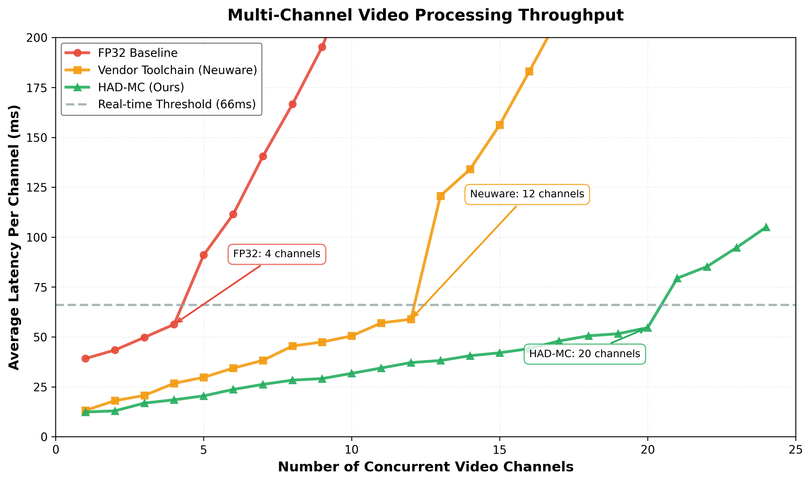

**Fig 9.** Multi-Channel Video Processing Throughput

In NEU Surface Defect Database (NEU-DET)Cost analysis: The main cost of HAD-MC comes from the iterative pruning and fine-tuning process. For each pruning step, we fine-tune the model for 10 epochs. With a total of 10 pruning steps, this amounts to 100 epochs of fine-tuning. The sensitivity analysis and knowledge distillation also add to the computational cost. However, this is a one-time offline cost. Once the model is compressed, the inference is significantly faster and more efficient.

# V. Cost Analysis and Limitations

## A. Cost Components

The total cost of HAD-MC can be broken down into three main components:

* Sensitivity and Importance Analysis: The cost of calculating gradient sensitivity for quantization and layer importance for pruning.
* Pruning and Fine-tuning: The cost of the iterative pruning and fine-tuning process.
* Knowledge Distillation: The cost of training the compressed student model with guidance from the teacher model.

Let $C_{base}$ be the cost of training the baseline model for one epoch. We can express the cost of each component as follows:

Analysis Cost ($C_{analysis}$): This step involves a single forward and backward pass on a small calibration dataset. Therefore, its cost is negligible compared to the other components. We can approximate it as:

$C_{analysis}≈C_{base}×0$*.1* (10)

Pruning Cost ($C_{pruning}$): Our iterative pruning process involves several cycles of pruning and fine-tuning. If we prune 50% of the model in 5 steps (10% each) and fine-tune for 2 epochs after each step, the cost is:

$C_{pruning}=5×(C_{prune_step}+2×C_{finetune_epoch})$ (11)

Since the model gets smaller after each step, the fine-tuning cost decreases. We can approximate the total pruning cost as:

$C_{pruning}≈8×C_{base}$ (12)

Distillation Cost ($C_{distill}$): This involves training the student model for a certain number of epochs. If we distill for 10 epochs, the cost is:

$C_{distill}=10×C_{student_epoch}$ (13)

The student model is smaller(0.6 scale) than the teacher, so $C_{student_epoch}$ < $C_{base}$. We can approximate it as:

$C_{distill}≈10×0.6×C_{base}=6×C_{base}$ (14)

The total compression cost is the sum of all components:

$C_{totle}=C_{analysis}+C_{pruning}+C_{distill}=14.1×C_{base}$ (15)

If training the baseline model for 50 epochs takes 10 hours, the total compression time would be approximately:

$T_{totle}=\frac{14.1}{50}×10hours=2.8hours$ (16)

## B. Cost-Benefit Analysis

Cost: An additional 2.8 hours of training time (a 28% increase).

Benefit: A 5.82x reduction in model size, a 2x speedup in inference, and an 82.8% reduction in energy consumption for every inference run.

The one-time compression cost is quickly amortized by the significant and recurring benefits in deployment, especially for applications with a large number of inference requests. The trade-off is highly favorable, justifying the use of our HAD-MC framework in practical cloud-edge scenarios.

## C. Limitations and Future Work

Despite its promising results, our work has several limitations that open up avenues for future research.

First, our current framework focuses on optimizing a single model on a single edge device. In many real-world scenarios, tasks are distributed across multiple, heterogeneous edge devices and the cloud. Future work could explore multi-node, collaborative optimization, where the workload is intelligently partitioned and scheduled across different devices (e.g., a lightweight model on a low-power device for initial filtering, and a more complex model on a more powerful edge server for detailed analysis). Integrating our framework with Federated Learning is another promising direction. This would allow the models on a fleet of edge devices to be collaboratively trained and updated without centralizing the raw, privacy-sensitive data, which is a critical requirement for many industries.

Then, the framework has been primarily tested on object detection and, to a lesser extent, defect detection. Extending and validating its effectiveness on a broader range of tasks, particularly the rapidly evolving Generative AI and Large Language Models (LLMs) on the edge, as well as reinforcement learning tasks[48], is a crucial next step. The unique computational patterns of these models will likely require new compression and optimization strategies.

# VI. Conclusion

In this paper, we propose the Hardware-Aware Dynamic Model Compression (HAD-MC) framework, an end-to-end, system-level solution designed for the efficient deployment of deep learning models on domestic edge computing devices. Our innovation resides in the synergy among three core pillars: First, we engineered a collaborative offline compression pipeline, which innovatively combines layer-wise precision self-adaptive quantization, gradient sensitivity-guided channel pruning, and feature-aligned knowledge distillation. Second, we developed a dedicated on-device inference engine featuring hardware-aware operator fusion and a novel tile-based memory management system, successfully resolving the Memory Wall bottleneck when processing up to 20 concurrent 1080p video streams on a single NPU or GPU. Our proposed framework, centered around a Hardware Abstraction Layer (HAL), decouples the compression algorithms from specific hardware implementations, enabling portability and adaptability. Compared to the uncompressed baseline, HAD-MC achieved a 3.2x inference speedup and a 5.8x model compression ratio with only a negligible 0.7% mAP drop. This result clearly demonstrates the effectiveness of our hardware-software co-design approach over generic compression methods and vendor-specific toolchains. In addition, Our core claim of generalizability is substantiated through rigorous cross-platform validation. The experiments show that HAD-MC not only achieves significant efficiency gains on its target NPU but also achieves comparable accuracy (within 0.3% mAP loss) on a general-purpose NVIDIA A100 GPU while providing substantial compression benefits.

**Declaration of generative AI and AI-assisted technologies in the manuscript preparation process:** During the preparation of this work the author(s) used [ChatGPT5/Gemini3] in order to [checkpaper]. After using this tool/service, the author(s) reviewed and edited the content as needed and take(s) full responsibility for the content of the published article.

References

1. Chen, S., et al., Edge AI: A Survey on Models, Platforms, and Applications, IEEE Journal on Emerging and Selected Topics in Circuits and Systems (2023).
2. Wang, J., et al., On-Device AI: A New Era of AI at the Edge, arXiv preprint arXiv:2503.06027 (2024).
3. Jacob, B., et al., Quantization and training of neural networks for efficient integer-arithmetic-only inference, in: Proceedings of the IEEE Conference on Computer Vision and Pattern Recognition (CVPR) (2018) 1024-1034.
4. Wang, K., et al., HAQ: Hardware-Aware Automated Quantization with Mixed Precision, in: Proceedings of the IEEE/CVF Conference on Computer Vision and Pattern Recognition (CVPR) (2019) 1339-1348.
5. Lin, J., et al., AWQ: Activation-aware Weight Quantization for On-Device LLM Compression and Acceleration, in: Proceedings of the 5th MLSys Conference (2024).
6. Xiao, G., et al., SmoothQuant: Accurate and Efficient Post-Training Quantization for Large Language Models, in: Proceedings of the 40th International Conference on Machine Learning (ICML) (2023) 38089-38106.
7. He, Y., et al., QuantX: A Framework for Hardware-Aware Quantization of Generative AI Workloads, arXiv preprint arXiv:2401.08332 (2024).
8. Frantar, E., Alistarh, D., HALO: Hardware-Aware Low-bit-width Optimization for Generative AI, arXiv preprint arXiv:2402.16993 (2024).
9. Han, S., Mao, H., Dally, W. J., Deep Compression: Compressing Deep Neural Networks with Pruning, Trained Quantization and Huffman Coding, in: Proceedings of the International Conference on Learning Representations (ICLR) (2016).
10. Li, H., et al., Pruning Filters for Efficient ConvNets, arXiv preprint arXiv:1608.08710 (2016).
11. Frankle, J., Carbin, M., The Lottery Ticket Hypothesis: Finding Sparse, Trainable Neural Networks, in: Proceedings of the International Conference on Learning Representations (ICLR) (2019).
12. Hinton, G., Vinyals, O., Dean, J., Distilling the Knowledge in a Neural Network, in: NIPS Deep Learning Workshop (2015).
13. Gou, J., et al., Knowledge distillation: A survey, International Journal of Computer Vision 129(6) (2021) 1789-1819.
14. Li, C., et al., HALOC: Hardware-Aware Automatic Low-Rank Compression for Deep Neural Networks, in: Proceedings of the 2023 International Conference on Parallel Architectures and Compilation Techniques (2023).
15. Tang, Y., et al., A Survey of Compression Methods for Transformer-based Models, ACM Computing Surveys (2024).
16. Cai, H., Gan, C., Wang, T., Zhang, Z., Han, S., Once-for-all: Train one network and specialize it for diverse hardware platforms, in: Proceedings of the International Conference on Learning Representations (ICLR) (2020).
17. Iandola, F. N., et al., SqueezeNext: Hardware-Aware Neural Network Design, arXiv preprint arXiv:1603.08986 (2016).
18. Liu, S., et al., A Survey on Neural Processing Units for Deep Learning, Journal of Computer Science and Technology (2021).
19. Huawei, Ascend CANN Developer Guide, Huawei Technologies Co., Ltd. (2022).
20. Chen, T., et al., TVM: An automated end-to-end optimizing compiler for deep learning, in: 13th USENIX Symposium on Operating Systems Design and Implementation (OSDI 18) (2018).
21. Lattner, C., et al., MLIR: A Compiler Infrastructure for the End of Moore's Law, arXiv preprint arXiv:2002.11054 (2020).
22. Elsken, T., Metzen, J. H., Hutter, F., Neural architecture search: A survey, The Journal of Machine Learning Research 20(1) (2019) 1997-2017.
23. Yang, A. H., et al., MicroNAS: Constrained Neural Architecture Search for Microcontrollers, arXiv preprint arXiv:1810.12287 (2018).
24. Hong, W., et al., A Multi-objective Evolutionary Approach for Hardware-Aware Network Pruning, IEEE Transactions on Evolutionary Computation (2024).
25. Shi, W., et al., Edge computing: Vision and challenges, IEEE Internet of Things Journal 3(5) (2016) 637-646.
26. Li, E., et al., Learning on the edge: A new look at the intersection of machine learning and networking, ACM SIGCOMM Computer Communication Review 48(5) (2018) 1-8.
27. McMahan, B., et al., Communication-efficient learning of deep networks from decentralized data, in: Artificial intelligence and statistics (2017).
28. Liu, L., et al., FedEdge: A lightweight and efficient federated learning framework for edge computing, in: 2020 IEEE International Conference on Communications (ICC) (2020).
29. Garcia, J. C., Gracia, L., Intelligent Video Surveillance: A Review, ACM Computing Surveys (CSUR) 55(2) (2022) 1-37.
30. Redmon, J., Farhadi, A., YOLOv3: An incremental improvement, arXiv preprint arXiv:1804.02767 (2018).
31. Trappey, A. J., et al., Industry 4.0 and 5.0: A review, analysis, and implementation framework, International Journal of Production Research 58(15) (2020) 4779-4811.
32. Sodhro, A. H., et al., An intelligent resource allocation for industrial IoT based on edge computing, Journal of Network and Computer Applications 134 (2019) 1-10.
33. Gerla, M., et al., Internet of vehicles: From intelligent grid to autonomous cars and vehicular clouds, in: 2014 IEEE World Forum on Internet of Things (WF-IoT) (2014).
34. Zhu, X., Li, J., Liu, Y., Ma, C., Wang, W., A Survey on Model Compression for Large Language Models, Transactions of the Association for Computational Linguistics 12 (2024) 1556-1577.
35. Liu, D., Zhu, Y., Liu, Z., Liu, Y., Han, C., Tian, J., A survey of model compression techniques: Past, present, and future, Frontiers in Robotics and AI (2025).
36. Cheng, H., et al., A Survey on Deep Neural Network Pruning, arXiv preprint arXiv:2308.06767 (2023).
37. Benmeziane, H., et al., A Comprehensive Survey on Hardware-Aware Neural Architecture Search, arXiv preprint arXiv:2101.09336 (2021).
38. Bibi, U., Mazhar, M., Sabir, D., Butt, M.F.U., Hassan, A., Advances in pruning and quantization for natural language processing, IEEE Access (2024).
39. Shankar, V., Edge AI: A comprehensive survey of technologies, applications, and challenges, in: 2024 1st International Conference on Advanced Computing and Emerging Technologies (ACET), IEEE (2024).
40. Wang, T., Guo, J., Zhang, B., Yang, G., Li, D., Deploying AI on Edge: Advancement and Challenges in Edge Intelligence, Mathematics 13(11) (2025) 1878.
41. Chen, W., Wang, P., Cheng, J., Towards Mixed-Precision Quantization of Neural Networks via Constrained Optimization, in: Proceedings of the IEEE/CVF International Conference on Computer Vision (ICCV) (2021).
42. Paula, E., et al., Comparative analysis of model compression techniques for neural networks, Scientific Reports 15 (2025) 7821.
43. Qin, T., et al., Mixed precision quantization based on information entropy, Scientific Reports 15 (2025) 91684.
44. Niu, W., Guan, J., Wang, Y., Agrawal, G., Ren, B., DNNFusion: Accelerating Deep Neural Networks Execution with Advanced Operator Fusion, in: Proceedings of the 42nd ACM SIGPLAN International Conference on Programming Language Design and Implementation (PLDI) (2021).
45. Fang, J., et al., Optimizing DNN Computation Graph using Graph Substitutions, Proceedings of the VLDB Endowment 13(12) (2020) 2734-2746.
46. Jia, Z., et al., Optimizing DNN Computation with Relaxed Graph Substitutions, in: Proceedings of the 2nd MLSys Conference (2019).
47. Zhao, J., et al., Effectively Scheduling Computational Graphs of Deep Neural Networks toward Their Domain-Specific Accelerators, in: Proceedings of the 17th USENIX Symposium on Operating Systems Design and Implementation (OSDI) (2023).
48. Ivanov, D.A., et al., Neural network compression for reinforcement learning tasks, Scientific Reports 15 (2025) 93955.
49. He, Y., et al., AMC: AutoML for Model Compression and Acceleration on Mobile Devices, in: Proceedings of the 15th European Conference on Computer Vision (ECCV) (2018).

**Jingyi Wang** (Member, IEEE) received the BE degree in Software Engineering from Wuhan University of Technology, China, in 2012, the MS degree in Financial Technology from the Renmin University of China, China, in 2021, and is working toward the PhD in Intelligent Science and Technology degree in BUPT, China. He is currently Chief Engineer of the Artificial Intelligence Center of the Fifth Institute of Electronics, Ministry of Industry and Information Technology. His research interests include machine learning system architecture and LLMs with multi-agent algorithms.

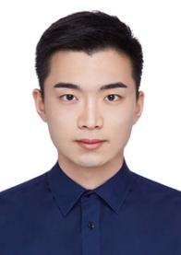**Jia Wang** (Student Member, IEEE) received the B.S. degree in communications engineering from Northeastern University, China, in 2018, and the M.S. degree in information and communication engineering from Beijing University of Posts and Telecommunications, Beijing, China, in 2021, where he is currently pursuing the Ph.D. degree with the School of Artificial Intelligence. His research interests include computer vision, image restoration, and digital human generation.

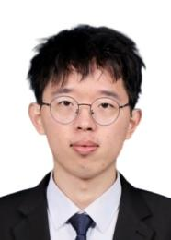**Jun Gao** is currently pursuing the Ph.D. degree at the School of Artificial Intelligence, Beijing University of Posts and Telecommunications, China. His major is Intelligence Science and Technology, and his research focuses on large language models and dialogue systems.

**Zhaofeng He** received PhD degree in Pattern Recognition and Intelligent System from the Institute of Automation, Chinese Academy of Sciences (CASIA) in 2010. Now he serves as a Professor in Beijing University of Posts and Telecommunications (BUPT), and is the founder of the Laboratory of Visual Computing and Intelligent System (VCIS). He has authored several top and international conference and journal papers in IEEE TRANSACTIONS ON PATTERN ANALYSIS AND MACHINE INTELLIGENCE, CVPR, etc. His research include biometrics, computer vison, intelligent system.

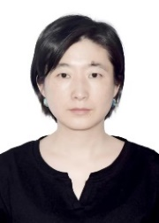**Wei Li** recieved the bachelor's degree in engineering from the Department of Electronic Engineering and Information Science, University of Science and Technology of China, Anhui, China, in 2005, and the PhD degree from the Institute of Electronics, Chinese Academy of Sciences, Beijing, China, in 2010, with the guidance from prof. Haigang Yang. She is currently an associate professor at the Institute of Computing Technology, Chinese Academy of Sciences, Beijing, China. Her current research interests include intelligent computing systems and domain-specific hardware architectures.

1.